C31 Parameter Estimation
David Housman

Concepts
- After obtaining data $x_{1},x_{2},…,x_{n}$ from a sample of a population, we summarize with a statistic $\hat{θ}\left(x_{1},x_{2},…,x_{n}\right)$ such as the mean, median, standard deviation, or interquartile range. This is part of descriptive statistics.
- We hope that the statistic $\hat{θ}$ tells us something about a population parameter $θ$ such as $λ$ in the Poisson random variable, $α$ and $β$ in the gamma random variable, or $p$ in the geometric random variable. In this context, the statistic $\hat{θ}$ is called an estimator for the population parameter $θ$. This is part of inferential statistics.
- Right now, we focus on probability. We start with a known population, modeled by a random variable $X$ governed by a parameter $θ$; take a sample, modeled by mutually independent random variables $X_{1},X_{2},…,X_{n}$ each having the same distribution as $X$; and study the statistic
- $\hat{θ}\left(X_{1},X_{2},…,X_{n}\right)$
- and its distribution (usually called a sampling distribution). Observe our use of capital letters when referring to random variables and lower case letters with referring to data.
- We hope that our statistics are unbiased (a statistic’s expected value $E\left[\hat{θ}\left(X_{1},X_{2},…,X_{n}\right)\right]$ equals the parameter $θ$ being estimated) and are precise (a statistic’s variance $\text{Var}\left[\hat{θ}\left(X_{1},X_{2},…,X_{n}\right)\right]$ is as small as possible).
- Recall that if $x$ and $Y$ are random variables and $a$ and $b$ are real numbers, then $E\left[aX+bY\right]=aE\left[X\right]+bE\left[Y\right]$ and $\text{Var}\left[aX+bY\right]=a^{2}\text{Var}\left[X\right]+b^{2}\text{Var}\left[Y\right]+2ab\text{Cov}\left(X,Y\right)$. If $X$ and $Y$ are also independent, then $\text{Var}\left[aX+bY\right]=a^{2}\text{Var}\left[X\right]+b^{2}\text{Var}\left[Y\right]$.
- Suppose x = c(1,2,3). Then rep(x, times = 4) returns c(1,2,3,1,2,3,1,2,3,1,2,3), and rep(x, each = 4) returns c(1,1,1,1,2,2,2,2,3,3,3,3).

Poisson Population Example
In an experiment conducted by Rutherford, Chadwick, and Ellis, a radioactive substance was observed during 2,608 time intervals of 7.5 seconds each; the number of particles reaching a counter was obtained for each period. The sample mean and variance were 3.87 and 3.68 particles, respectively, and we wondered whether this data could have arisen from a Poisson distribution with mean around 3.87. This is an inferential statistics question. Let us answer a related probability question: For a population modeled by a Poisson distribution with $λ=3.87$, what would samples of size 2,608 look like?
- Generate a sample of size 2,608 from a Poisson random variable with parameter $λ=3.87$. Describe the sample with a histogram, mean, and variance. Repeat a few times to get some intuition about the amount of variation in the sample histograms, means, and variances.
n = 2608
lambda = 3.87
sample = tibble(x = rpois(n, lambda))
ggplot(sample, aes(x = x)) + geom_histogram(binwidth = 1, center = 0, color = "white")
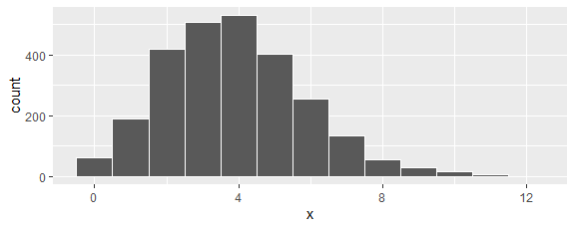
sample |> summarise(mean(x), var(x))
# A tibble: 1 × 2
`mean(x)` `var(x)`
<dbl> <dbl>
1 3.87 3.82
- Simulate 10,000 samples of size 2,608 from a Poisson distribution with $λ=3.87$. Save in a tibble named samples with columns run and x.
nruns = 10000
n = 2608
lambda = 3.87
samples = tibble(
run = rep(1:nruns, each = n),
x = rpois(nruns*n, lambda))

Sample Mean Statistic $\overset{‾}{X}$
Suppose $X_{1},X_{2},…,X_{n}$ are independent identically distributed random variables each having mean $μ$ and standard deviation $σ$. Let the sample mean statistic
$$\overset{‾}{X}=\frac{1}{n}\left(X_{1}+X_{2}+⋯+X_{n}\right)$$
be an estimator for the population mean $μ$.
- Calculate the mean for each sample in samples. Display a histogram of the sample means. Calculate the mean of the sample means, the standard deviation of the sample means, and the interval within which 95% of the sample means lie. Write a sentence summarizing the results. How might this provide an inference from the original data?
means = samples |> group_by(run) |> summarise(xbar = mean(x))
ggplot(means, aes(x = xbar)) +
geom_histogram()
`stat_bin()` using `bins = 30`. Pick better value with `binwidth`.
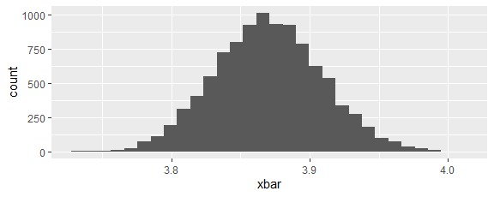
means |> summarise(
mean = mean(xbar),
sd = sd(xbar),
lo = quantile(xbar, 0.025),
hi = quantile(xbar, 0.975)
)
# A tibble: 1 × 4
mean sd lo hi
<dbl> <dbl> <dbl> <dbl>
1 3.87 0.0390 3.79 3.95
The distribution of sample means looks bell shaped with a mean of 3.87, standard deviation of 0.04, and a 95% coverage interval of 3.79 to 3.95.
- Determine the mean, variance, standard deviation, and distribution of the random variable $\overset{‾}{X}$ in general. Apply these results when each $X_{i}$ is $\text{Poisson}\left(3.87\right)$. How is this related to the previous exercise?
The mean of $\overset{‾}{X}$ is
$$\begin{matrix}μ_{\overset{‾}{X}} & = & E\left[\overset{‾}{X}\right] \\ & = & E\left[\frac{1}{n}\left(X_{1}+X_{2}+⋯+X_{n}\right)\right] \\ & = & \frac{1}{n}\left(E\left[X_{1}\right]+E\left[X_{2}\right]+⋯+E\left[X_{n}\right]\right) \\ & = & \frac{1}{n}\left(μ+μ+⋯+μ\right) \\ & = & μ.\end{matrix}$$
The variance of $\overset{‾}{X}$ (using independence) is
$$\begin{matrix}\text{Var}\left[\overset{‾}{X}\right] & = & \text{Var}\left[\frac{1}{n}\left(X_{1}+X_{2}+⋯+X_{n}\right)\right] \\ & = & \frac{1}{n^{2}}\left(\text{Var}\left[X_{1}\right]+\text{Var}\left[X_{2}\right]+⋯+\text{Var}\left[X_{n}\right]\right) \\ & = & \frac{1}{n^{2}}\left(σ^{2}+σ^{2}+⋯+σ^{2}\right) \\ & = & \frac{1}{n}σ^{2}.\end{matrix}$$
The standard deviation is
$σ_{\overset{‾}{X}}=\sqrt{\text{Var}\left[\overset{‾}{X}\right]}=\sqrt{\frac{1}{n}σ^{2}}=\frac{σ}{\sqrt{n}}.$
The Central Limit Theorem tells us that the distribution of $\overset{‾}{X}$ is approximately normal for sufficiently large $n$.
For $X_{i}∼\text{Poisson}\left(3.87\right)$ and $n=2608$, $μ_{\overset{‾}{X}}=3.87$ and $σ_{\overset{‾}{X}}=\sqrt{3.87/2608}=0.0385$, and the central 95% of the sample means should be in 3.87 ± 0.08 particles per period. This matches what we found in the previous exercise because that was a simulation of $\overset{‾}{X}$.
means |> summarise(
smean = mean(xbar),
tmean = lambda,
ssd = sd(xbar),
tsd = sqrt(lambda/n)
)
# A tibble: 1 × 4
smean tmean ssd tsd
<dbl> <dbl> <dbl> <dbl>
1 3.87 3.87 0.0390 0.0385
ggplot(means, aes(x = xbar)) +
geom_histogram(aes(y = after_stat(density))) +
geom_function(fun = dnorm, args = list(mean = lambda, sd = sqrt(lambda/n)), color = "red", linewidth = 2)
`stat_bin()` using `bins = 30`. Pick better value with `binwidth`.
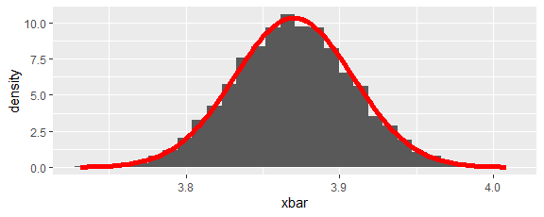
- What do the results from the previous exercise tell us about the use of the statistic $\overset{‾}{X}$ to estimate the parameter $μ$ of a population?

Sample Variance Statistic $S^{2}$
Suppose $X_{1},X_{2},…,X_{n}$ are independent identically distributed random variables each having mean $μ$ and standard deviation $σ$. Let the sample variance statistic
$$S^{2}=\frac{1}{n−1}\left({\left(X_{1}−\overset{‾}{X}\right)}^{2}+{\left(X_{2}−\overset{‾}{X}\right)}^{2}+⋯{\left(X_{n}−\overset{‾}{X}\right)}^{2}\right)$$
be an estimate for the population variance $σ^{2}$.
- Calculate the variance for each sample in samples. Display a histogram of the sample variances. Calculate the mean of the sample variances, the standard deviation of the sample variances, and the interval within which 95% of the sample variances lie. Write a sentence summarizing the results. How might this provide an inference from the original data?
vars = samples |> group_by(run) |> summarise(s2 = var(x))
ggplot(vars, aes(x = s2)) +
geom_histogram()
`stat_bin()` using `bins = 30`. Pick better value with `binwidth`.
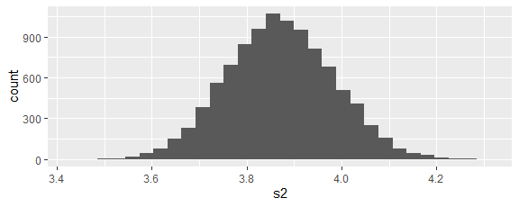
vars |> summarise(
mean = mean(s2),
sd = sd(s2),
lo = quantile(s2, 0.025),
hi = quantile(s2, 0.975)
)
# A tibble: 1 × 4
mean sd lo hi
<dbl> <dbl> <dbl> <dbl>
1 3.87 0.113 3.65 4.09
- Determine the mean, variance, standard deviation, and distribution of the random variable $S^{2}$. Apply these results when each $X_{i}$ is $\text{Poisson}\left(3.87\right)$. How is this related to the previous exercise?
Consider
$$\begin{matrix}E\left[\left(n−1\right)S^{2}\right] & = & E\left[\sum_{i=1}^{n}{{\left(X_{i}−\overset{‾}{X}\right)}^{2}}\right] \\ & = & E\left[\sum_{i=1}^{n}{{\left(\left(X_{i}−μ\right)−\left(\overset{‾}{X}−μ\right)\right)}^{2}}\right] \\ & = & E\left[\sum_{i=1}^{n}{\left({\left(X_{i}−μ\right)}^{2}−2\left(X_{i}−μ\right)\left(\overset{‾}{X}−μ\right)+{\left(\overset{‾}{X}−μ\right)}^{2}\right)}\right] \\ & = & E\left[\sum_{i=1}^{n}{\left({\left(X_{i}−μ\right)}^{2}−2\left(X_{i}−μ\right)\frac{1}{n}\sum_{j=1}^{n}{\left(X_{j}−μ\right)}+{\left(\overset{‾}{X}−μ\right)}^{2}\right)}\right] \\ & = & \sum_{i=1}^{n}{E}\left[{\left(X_{i}−μ\right)}^{2}\right]−\frac{2}{n}\sum_{i=1}^{n}{\sum_{j=1}^{n}{E}}\left[\left(X_{i}−μ\right)\left(X_{j}−μ\right)\right]+\sum_{i=1}^{n}{E}\left[{\left(\overset{‾}{X}−μ\right)}^{2}\right] \\ & = & nσ^{2}−\frac{2}{n}nσ^{2}+n\frac{σ^{2}}{n} \\ & = & \left(n−1\right)σ^{2}\end{matrix}$$
Thus, the mean of $S^{2}$ is
$E\left[S^{2}\right]=σ^{2}$.
It can be shown (https://math.stackexchange.com/questions/72975/variance-of-sample-variance) that
$\text{Var}\left(S^{2}\right)=\frac{μ_{4}}{n}−\frac{σ^{4}\left(n−3\right)}{n\left(n−1\right)}$
where $μ_{4}=E\left[{\left(X−μ\right)}^{4}\right]$ is the fourth central moment of $X$.
A corollary to the Central Limit Theorem is that the distribution of $S^{2}$ is approximately normal for large sample sizes (https://math.stackexchange.com/questions/2325500/central-limit-theorem-for-the-variance#mjx-eqn-2).
For $X_{i}∼\text{Poisson}\left(3.87\right)$ (the s values arise from our simulation and the t values arise from the above theory):
vars |> summarise(
smean = mean(s2),
tmean = lambda,
ssd = sd(s2),
tsd = sqrt((3*lambda^2+lambda)/n - lambda^2*(n-3)/n/(n-1))
)
# A tibble: 1 × 4
smean tmean ssd tsd
<dbl> <dbl> <dbl> <dbl>
1 3.87 3.87 0.113 0.114
The histogram is of the simulated $S^{2}$ and the red curve is of the theoretical pdf for $S^{2}$:
ggplot(vars, aes(x = s2)) +
geom_histogram(aes(y = after_stat(density))) +
geom_function(fun = dnorm, args = list(mean = lambda, sd = sqrt((3*lambda^2+lambda)/n - lambda^2*(n-3)/n/(n-1))), color = "red", linewidth = 2)
`stat_bin()` using `bins = 30`. Pick better value with `binwidth`.
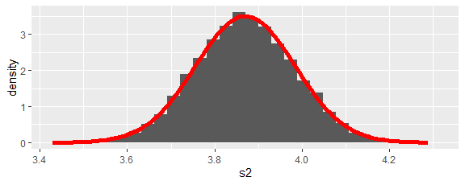
- What do the results from the previous exercise tell us about the use of the statistic $S^{2}$ to estimate the parameter $σ^{2}$ of a population?
- What do the results from exercises 4 and 7 tell us about the use of the statistics $\overset{‾}{X}$ and $S^{2}$ to estimate the parameter $λ$ of a Poisson population?

Finding Estimators
Two approaches to finding a statistic to estimate a parameter are the method of moments and maximizing likelihood. We illustrate these approaches via some examples.
- Find the method of moments estimators for the mean $μ$ and variance $σ^{2}$ of a normal population.
The central moments of a random variable $X$ are $μ_{1}=E\left[X\right]$ and $μ_{k}=E\left[{\left(X−μ_{1}\right)}^{k}\right]$ for positive integers $k$.
If $X$ is randomly selecting an element from a list of data $x_{1},x_{2},…,x_{n}$, then $μ_{1}=\frac{1}{n}\sum_{i=1}^{n}{x_{i}}=\overset{‾}{x}$ and $μ_{2}=\frac{1}{n}\sum_{i=1}^{n}{{\left(x_{i}−\overset{‾}{x}\right)}^{2}}=\frac{n−1}{n}s^{2}=v$.
If $X$ is a normal distribution with mean $μ$ and standard deviation $σ$, then $μ_{1}=μ$ and $μ_{2}=σ^{2}$.
Matching the first two central moments yields $\hat{μ}=\frac{1}{n}\sum_{i=1}^{n}{x_{i}}$ and $\hat{σ^{2}}=\frac{1}{n}\sum_{i=1}^{n}{{\left(x_{i}−\overset{‾}{x}\right)}^{2}}$.
Note that $\hat{μ}$ is the sample mean but $\hat{σ^{2}}$ is the natural but biased $\frac{n−1}{n}$ times the sample variance. Note also that neither $S$ nor $\sqrt{V}$ is an unbiased estimator for $σ$.
- Find the method of moments estimator for the mean $λ$ of a Poisson population.
If $X$ is a Poisson distribution with mean $λ$, then $μ_{1}=λ$. Matching the first central moments yields $\hat{λ}=\frac{1}{n}\sum_{i=1}^{n}{x_{i}}$.
- Find the maximum likelihood estimator for the mean $λ$ of a Poisson population.
Our population $X$ has a pdf of the form $f\left(x\right)=e^{−λ}\frac{λ^{x}}{x!}$ for $x=0,1,2,…$ where $λ>0$ is unknown. We obtain data $x_{1},x_{2},…,x_{n}$ from a sample of the population and endeavor to estimate the parameter $λ$. The probability (called likelihood in this context) that a sample from the given population would be the same as our actual data is
$L\left(λ\right)=\prod_{i=1}^{n}{f}\left(x_{i}\right)=\prod_{i=1}^{n}{e^{−λ}}\frac{λ^{x_{i}}}{x_{i}!}$.
We want to choose our parameter $λ$ so as to maximize the likelihood $L\left(λ\right)$. It is often easier to maximize the log likelihood:
$$\begin{matrix}l\left(λ\right) & = & ln\left(L\left(λ\right)\right) \\ & = & \sum_{i=1}^{n}{\left(ln\left(e^{−λ}\right)+ln\left(λ^{x_{i}}\right)−ln\left(x_{i}!\right)\right)} \\ & = & −nλ+ln\left(λ\right)\sum_{i=1}^{n}{x_{i}}−\sum_{i=1}^{n}{ln}\left(x_{i}!\right)\end{matrix}$$
A necessary condition to maximize $l$ comes from calculus:
$0=l′\left(\hat{λ}\right)=−n+\frac{1}{\hat{λ}}\sum_{i=1}^{n}{x_{i}}$
The unique solution is
$\hat{λ}=\frac{1}{n}\sum_{i=1}^{n}{x_{i}}$.
It is easy to verify with a first derivative test that this is a global maximum.

Gamma Population
Suppose we have a gamma population with unknown parameters $α$ and $β$. We obtain a sample $x_{1},x_{2},…,x_{n}$ and want to estimate the population parameters.
- Find the method of moments estimators.
Recall from C25 Important Random Variables that for $\text{Gamma}\left(α,β\right)$, the mean is $μ=αβ$ and the variance is $σ^{2}=αβ^{2}$. By solving these two equations for the parameters, we obtain $β=σ^{2}/μ$ and $α=μ^{2}/σ^{2}$. Thus, the method of moments estimators are $\hat{α}={\overset{‾}{x}}^{2}/v$ and $\hat{β}=v/\overset{‾}{x}$ where $v=\frac{n−1}{n}s^{2}$.
- Find the maximum likelihood estimators.
Recall from C25 Important Random Variables that for $\text{Gamma}\left(α,β\right)$, the pdf is $f\left(x\right)=\frac{1}{Γ\left(α\right)β^{α}}x^{α−1}e^{−x/β}$ for $x≥0$ where $Γ\left(α\right)=\int_{0}^{∞}{t^{α−1}}e^{−t}dt$ is a generalization of $\left(α−1\right)!$. Thus, the log likelihood function is
$$\begin{matrix}l\left(α,β\right) & = & \sum_{i=1}^{n}{ln}\left(\frac{1}{Γ\left(α\right)β^{α}}x_{i}^{α−1}e^{−x_{i}/β}\right) \\ & = & −nln\left(Γ\left(α\right)\right)−nαln\left(β\right)+\left(α−1\right)\left(\sum_{i=1}^{n}{ln}\left(x_{i}\right)\right)−\frac{1}{β}\sum_{i=1}^{n}{x_{i}}\end{matrix}$$
Necessary conditions to maximize $l$ are
$0=\frac{∂l}{∂α}=−n\frac{Γ′\left(α\right)}{Γ\left(α\right)}−nln\left(β\right)+\sum_{i=1}^{n}{ln}\left(x_{i}\right)$
and
$0=\frac{∂l}{∂β}=−n\frac{α}{β}+\frac{1}{β^{2}}\sum_{i=1}^{n}{x_{i}}$.
The second equation yields
$\hat{α}\hat{β}=\overset{‾}{x}$
but the first equation is not very helpful symbolically. We must find a numerical solution for any given list of data.
- Suppose the data given below came from a gamma population. Find the method of moments estimators and maximum likelihood estimators. Compare the empirical cdf and the two theoretical cdfs in a single plot.
actual = tibble(x = c(49.2,53.9,50.0,44.5,42.2,42.3,32.3,31.3,60.9,47.5))
moments = actual |> summarize(
n = n(),
xbar = mean(x),
v = (n-1)/n * var(x),
alpha = xbar^2 / v,
beta = v / xbar
)
moments
# A tibble: 1 × 5
n xbar v alpha beta
<int> <dbl> <dbl> <dbl> <dbl>
1 10 45.4 74.4 27.7 1.64
likelihood = actual |> summarize(
n = n(),
xbar = mean(x),
v = (n-1)/n * var(x),
alpha = uniroot(function(a) -n*digamma(a) - n*log(xbar/a) + sum(log(x)), c(10, 40))$root,
beta = xbar / alpha
)
likelihood
# A tibble: 1 × 5
n xbar v alpha beta
<int> <dbl> <dbl> <dbl> <dbl>
1 10 45.4 74.4 26.4 1.72
ggplot(actual, aes(x = x)) +
stat_ecdf() +
geom_function(fun = pgamma, args = list(shape = moments$alpha, scale = moments$beta), xlim = c(29, 63), color = "red") +
geom_function(fun = pgamma, args = list(shape = likelihood$alpha, scale = likelihood$beta), xlim = c(29, 63), color = "blue")
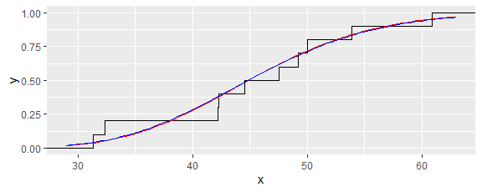
It appears that the data could have come from a gamma population and that the two theoretical distributions are quite similar.

