For the following circuits, draw the Thevenin equivalent circuit and determine the Thevenin voltage and resistance.

A B C

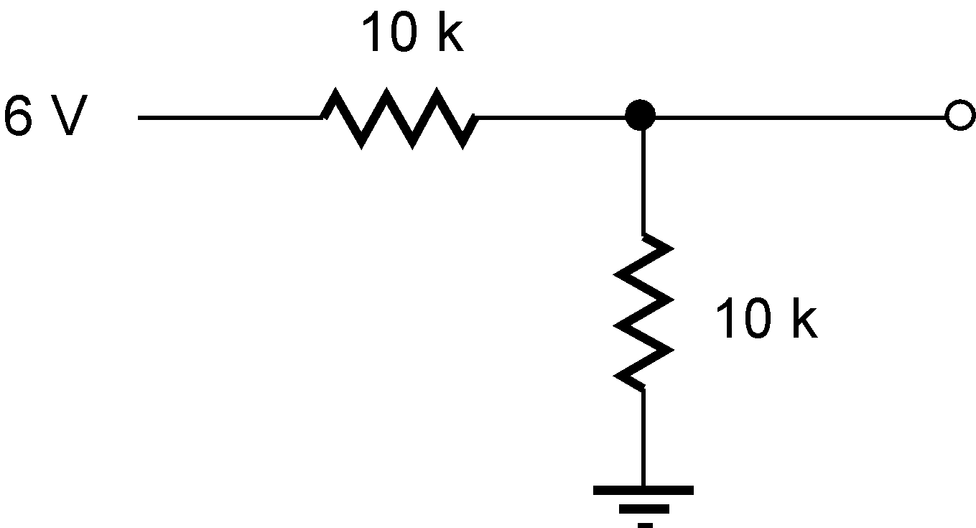
D E F
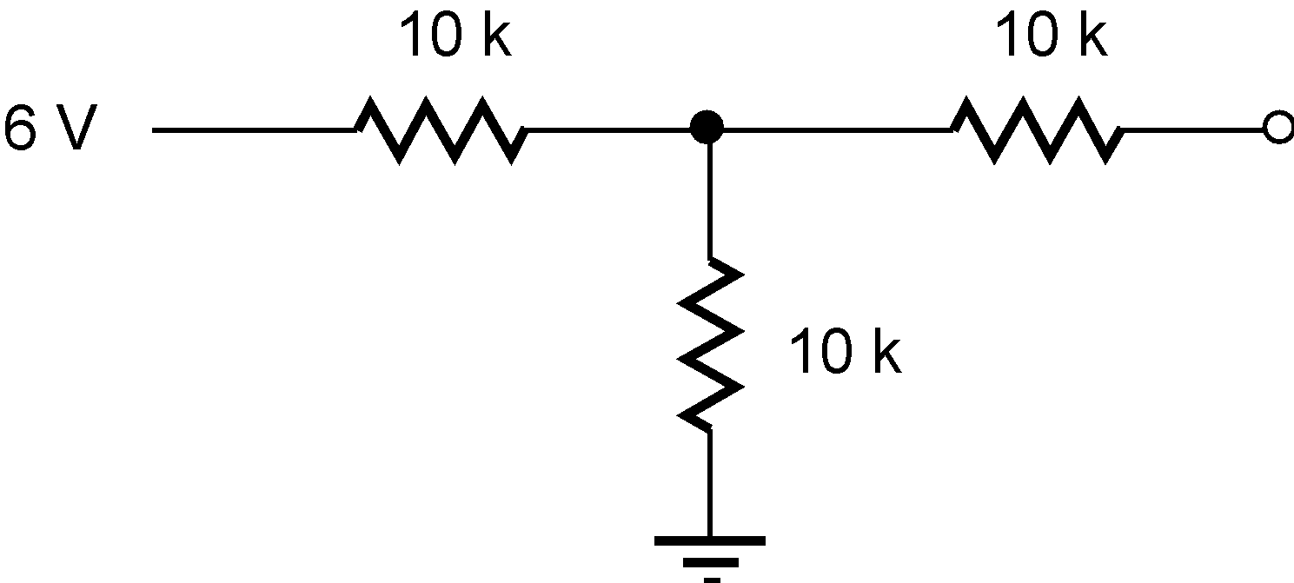
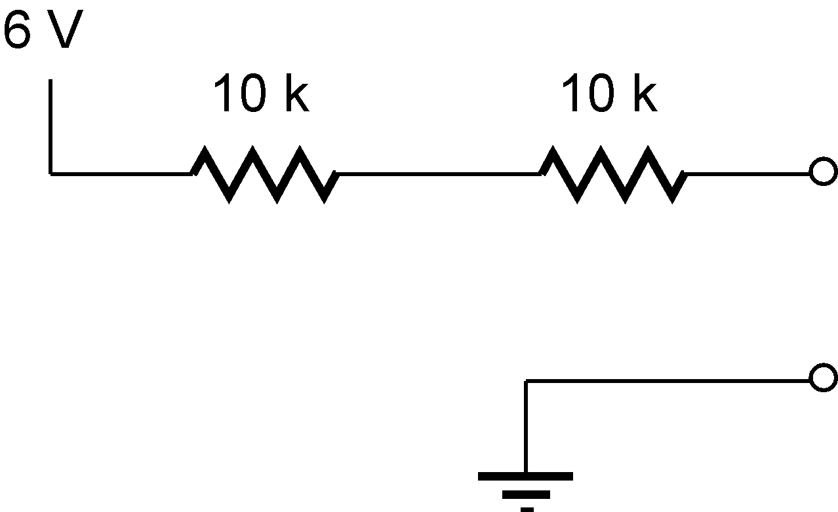

G H I

J K L

M. Find the input impedance (input resistance with respect to ground) of the following circuit. The “box” has an input impedance of 600 ohms (treat it as an input resistance of 600 ohms). So you’re trying to find the input resistance looking into the input of the entire circuit including the effect of the box.

- A signal generator has a 50 ohm output impedance. When connected to a stereo amplifier, its output decreases very slightly from 4.0 V p-p down to 3.8 V p-p. (p-p=peak to peak means AC voltage measured by the difference between the highest voltage and the lowest voltage as V varies in time.) What is the input impedance of the stereo amp?

- A good digital meter (good means has a very high input impedance, typically 1 mega ohm or greater) is connected to a battery and measures its output to be 8.72 V. Then a 150 ohm resistor is connected across the battery terminals and the meter reads 8.65 V. What is the internal resistance of the battery?

- From a 9 volt battery, produce a 5 Volt supply for logic circuits which may use anything from zero to 100 mA. They require the voltage to be within 0.5 volts of the design (5V) value.

- I have an old stereo tuner that picks up WGCS but its output is a 600 ohms “line level” (this means its output impedance is 600 ohms). I want to hear WGCS from a pair of (unpowered) 8 ohm speakers I have. What will happen if I just connect them? What do I need to make this work better?

-------

- If I connect two 9-volt batteries (each with an internal resistance of about 1 ohm) in series to get 18 volts, that’s more than a car battery which is 12 volts. What would happen if I connected the 9-volt batteries to a dead car battery to try to start the car? (Google to find the typical current needed to start a car.)

- From a 12 volt battery (internal resistance of less than 1 ohm), design an output circuit that could supply 1.5 volts for indicator lights. They use 30 mA each and you might have one two or three of them connected in parallel. Keep the voltage within 10% of the correct value.

